**GEOGRAPHIC INFORMATION SYSTEMS 1 – SCIENTIFIC DATA**

**UMEÅ UNIVERSITY – DEPARTMENT OF ECOLOGY & ENVIRONMENTAL SCIENCE**

**LAB5 – ANALYSIS FOR THE RELOCATION OF THE CITY OF KIRUNA**

**LAB5.1 Introduction**

**LAB5.2 Methods**

**LAB5.3 Results**

**LAB5.4 Discussion**

**LAB5.1 – INTRODUCTION**

Given the mining-related subsidence of some urban areas of the city of Kiruna, in Norrbotten County, which have been detected since decades ago, a significant number of territorial assessments and masterplans for the relocation of the entire city have been developed since 2004. The analysis proposed in this report comes from the necessity of providing a geologically stable base to all urban areas of the city in the future.

The aim is to support the selection of potential areas as optimal for the location of new urban settlements, by analysing a number of pre-considered geographical, geological, and environmental factors, i.e. the proximity to mining activities or main transportation infrastructures, the depth and type of bedrock underneath, the preservation of natural protected and other areas of interest, and so on. Additionally, other factors such depth of bedrock, which is decisive in architectural foundation design, can be also considerably important when it comes to ensure an optimal stability of the areas selected to build the new city.

**LAB5.2 – METHODS**

In order to properly analyse the collected geodata, and to later present its results, a considerable number of storage and manipulation methods/tools have been used, which are descripted hereunder:

1. A new **geodatabase**, GIS1_Lab5_final_project.gdb, has been created to conveniently store the big amount of raster and vector files, which have been mostly downloaded from SLU maps service. Following this method, feature class names become more intelligible and can be also organised into feature datasets, which will be essential to easily manipulate this information.
2. By using the tool ‘**Project**’, which can be found in ‘ArcToolbox\Data Management Tools\Projections and Transformations’, shapefiles with a different coordinate system can be projected into the desired coordinate system and store it in the geodatabase, all in one operation.
3. The tool ‘**Buffer**’, which can be found in ‘ArcToolbox\Analysis Tools\Proximity’, has been used to apply conditions (*) to certain areas in whose influence area new urban settlements should not be built, e.g. around mining area (3km), around Kiruna Airport (2km), and around nature protection areas (1km).
4. ‘**Editor**’ tool has been used to digitise different layers, such as ‘study_area’, ‘geology_depth_bedrock’, or ‘urban_mine’.
5. The tool ‘**Clip**’, which can be found in ‘ArcToolbox\Analysis Tools\Extract’, has been used to adjust some layers such as ‘nature_protection_polygon_buffer1000’ to the study area.
6. ‘**Add field**’ tool has been used in layers such as ‘urban_mine_buffer3000’, ‘urban_airport_buffer2000’, ‘geology_depth_bedrock’, and ‘nature_protection_polygon_buffer1000_clip’, in order to manually specify whether each feature is suitable for new settlements or not. The created fields are of type ‘text’ and length ‘3’ (“YES” or “NO”)

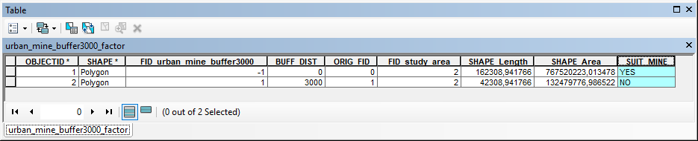

1. By using ‘**Union**’ tool, which can be found in ‘ArcToolbox\Analysis Tools\Overlay’, a union of each suitability factor (e.g. urban_mine_buffer3000) with the study_area has been done. The obtained layers contain those areas that are suitable for a new settlement, and those which are not. The tool ‘Union’ has been used to join all suitability factor layers in one, so a selection by attributes can be done to apply all suitability conditions and extract those areas which are suitable for a new settlement. By unckecking the option ‘gaps allowed’, we can make sure that no polygons contained within other polygons will be ignored during the operation.

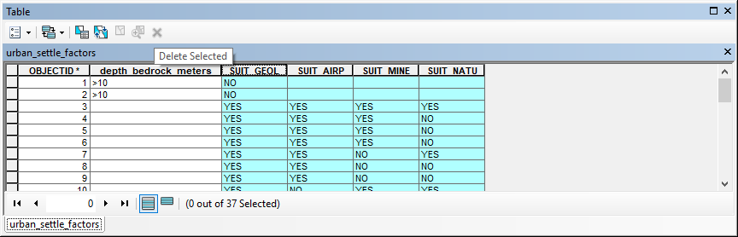

1. ‘**Select by attributes**’ has been used to select areas that fulfil the established conditions for a new settlement.

By applying the following expression, suitable areas for settlement will be selected:

SUIT_GEOL = 'YES' AND SUIT_AIRP = 'YES' AND SUIT_MINE = 'YES' AND SUIT_NATU = 'YES'

1. By using the tool ‘**export data**’, the selection described in bullet point 8 can be saved into a new layer within the geodatabase.
2. The ‘**Erase**’ tool, which can be found in ‘ArcToolbox\Analysis Tools\Overlay’, has been used to delete some areas from certain layers, e.g. to delete water surfaces from suitable areas for settlements. This has been also used to make ‘rings of influence’, i.e. rings of 0 to 5km, 5 to 10km, and 10 to 15km, for which Kiruna Central Station is the centre.
3. The ‘**Intersect**’ tool, which can be found in ‘ArcToolbox\Analysis Tools\Overlay’, has been used to intersect the selection described in bullet point 8 with the layer ‘infrastructures_railway_stations_buffer5000’, in order to obtain a new layer that shows the suitable areas which are in a radius of 5km from Kiruna Central Station. The same has been done with ‘infrastructures_railway_stations_buffer5000to10000’ and ‘infrastructures_railway_stations_buffer10000to15000’ layers.

Notes

(*) Conditions to geographically exclude some areas as suitable for a new residential settlement have been set on a personal basis and only after a considerably short and limited research of factors, in order to provide sufficient data and conditions to be analysed within this exercise. Thus, areas such as Kiruna Airport, mining areas, and nature protected areas, as well as a certain area of influence around them, have been considered as not suitable for this purpose.

**LAB5.3 – RESULTS**

**LAB5.3.1 MAP 1** – Colour map version.

This is a slide version of the map for the analysis of the city of Kiruna and surroundings for the relocation of the city, which can be used for a slide presentation.

The map has been shown over a hillshade model of the study area and aims to show the factors considered to support certain areas as suitable the future settlement of the city of Kiruna.

A number of conditions regarding to minimum distance to nature protected areas, to mining activities area, and to Kiruna Airport premises have been overlaid on the map. Additionally, areas where the depth of bedrock is higher than 10m have been also overlaid, since these will be also ruled out.

As a result, areas which are not affected by these conditions have been highlighted on the map to evidence their suitability.

**LAB5.3.2 MAP 2** – B&W map version.

This is a black and white version of the map for the analysis of the city of Kiruna and surroundings for the relocation of the city, which can be used as a B&W figure within a report.

Data from map 1 has been used to produce this map.

**LAB5.3.3 MAP 3** – KML map version.

This is a KML version of the map for the analysis of the city of Kiruna and surroundings for the relocation of the city, which can be visualised in Google Earth Pro.

Data from map 1 has been used to produce this map.

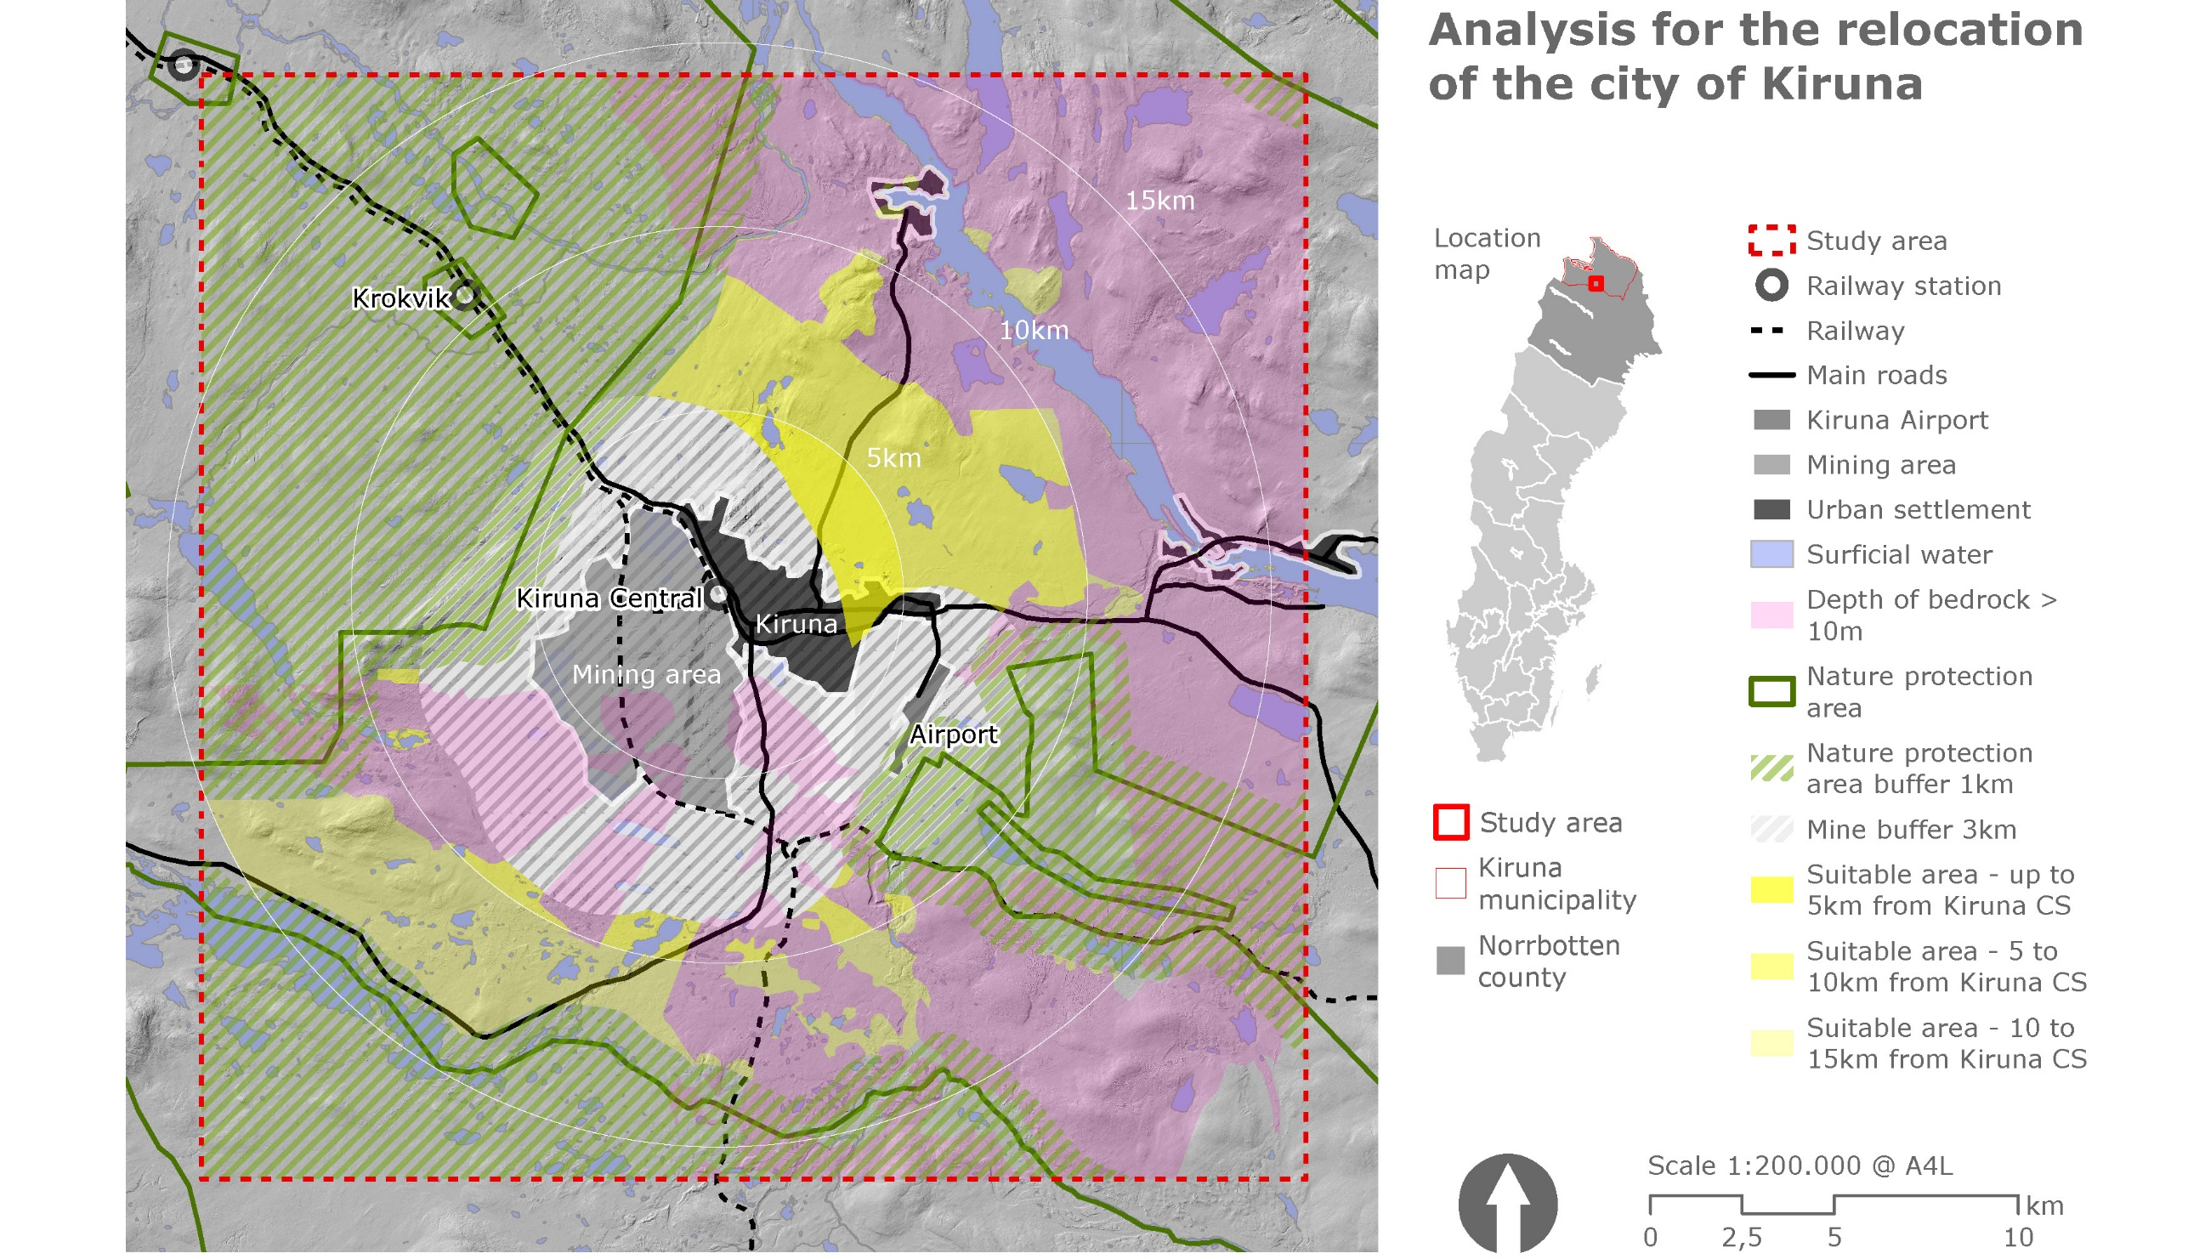

**Figure LAB5.3.1** - Version for slide presentation. Analysis of the city of Kiruna and surroundings for the relocation of the city, due to ground subsidence caused by the adjacent iron mine. A hillshade model has been used as a base, and conditions for a suitable location have been established, such as minimum distance to nature protected areas, to mining activities area, or to Kiruna Airport premises. Other conditions, such as depth of bedrock, is considered as essential to provide a stable base to the future city.

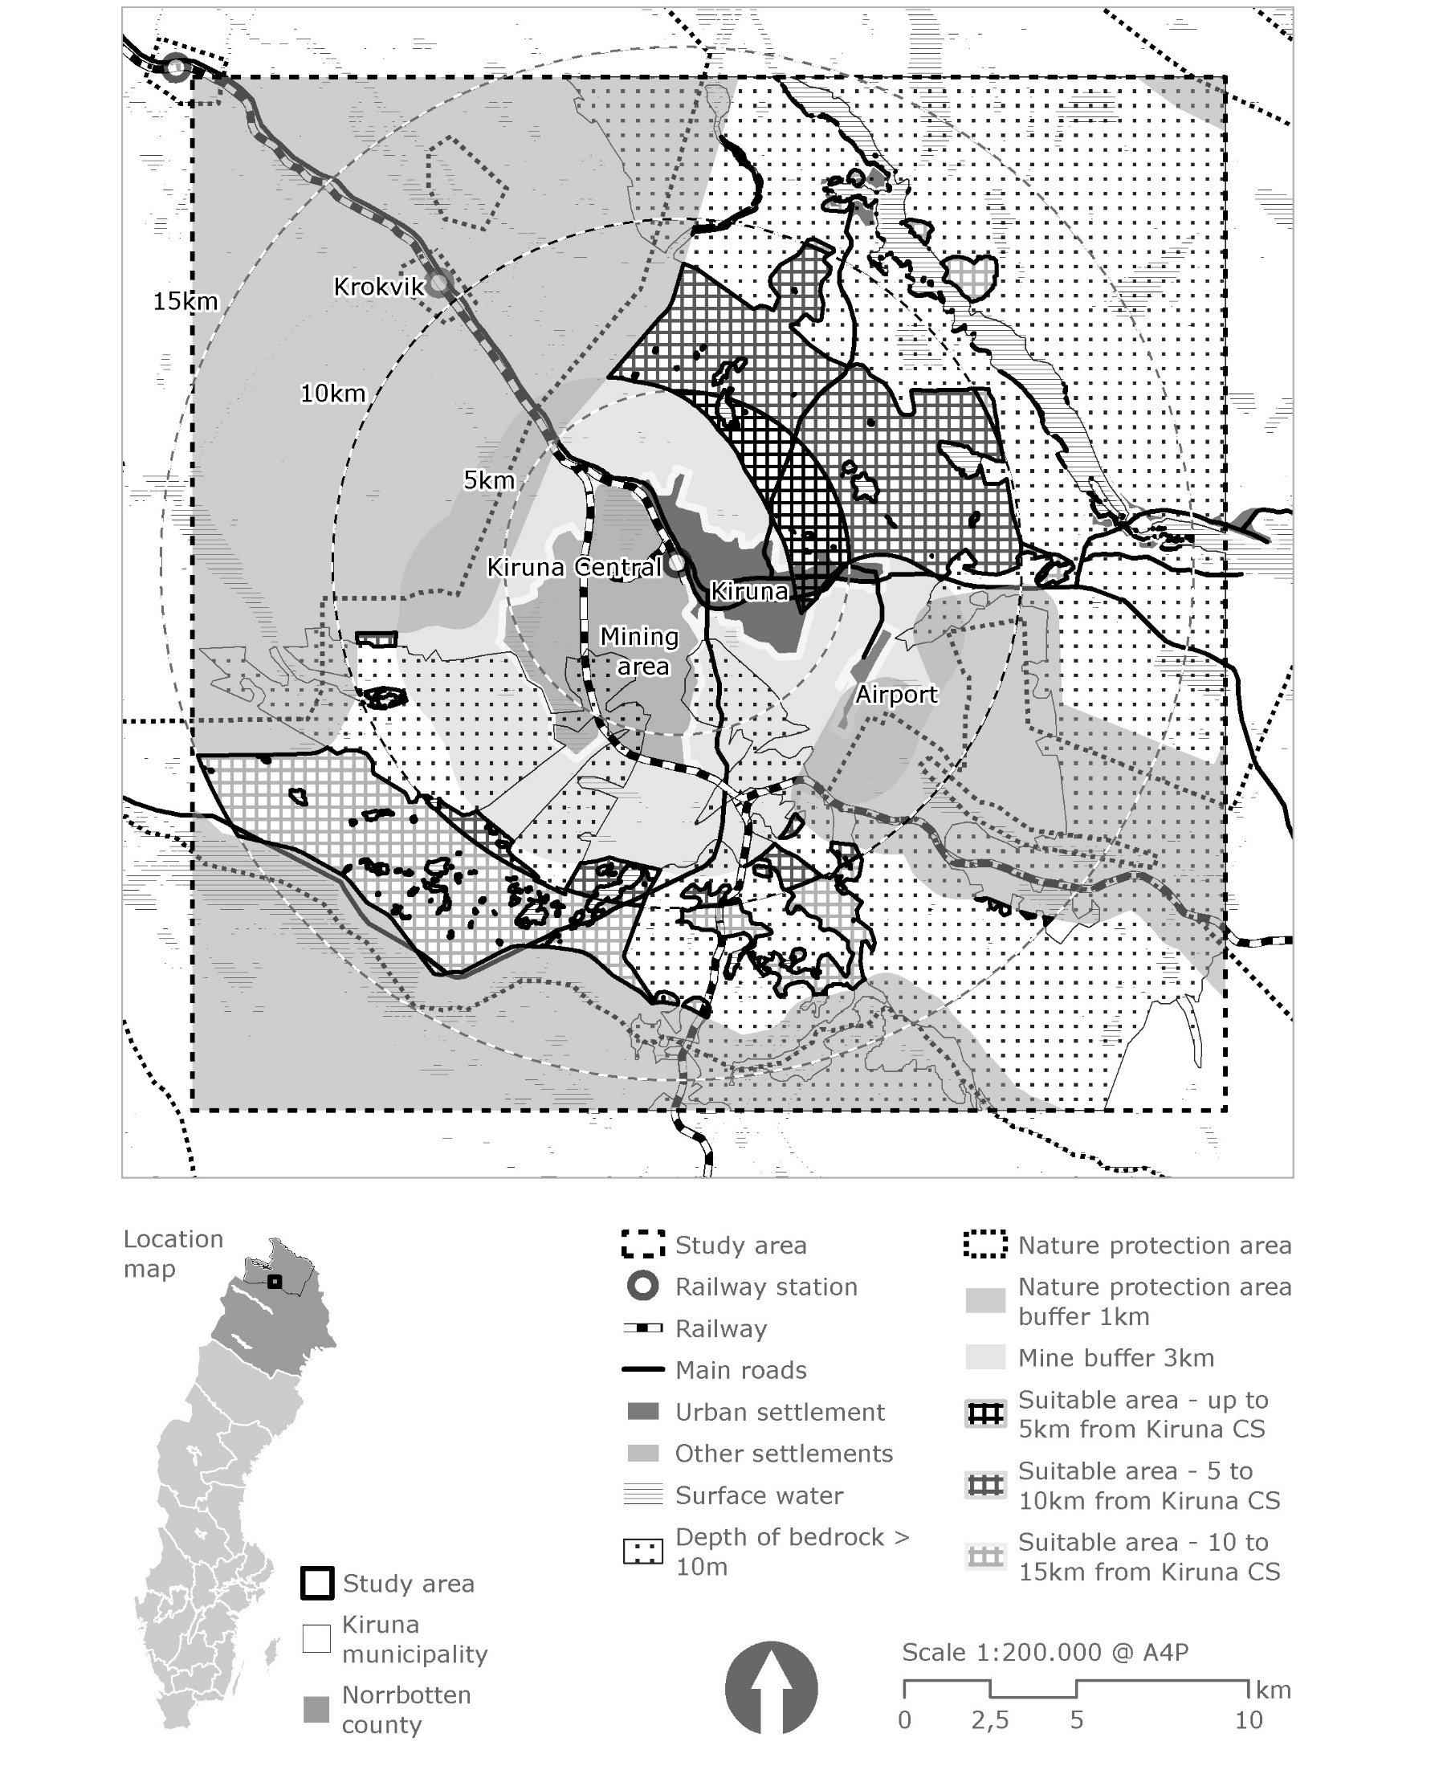

**Figure LAB5.3.2** - Analysis of the city of Kiruna and surroundings for the relocation of the city, due to ground subsidence caused by the adjacent iron mine. A hillshade model has been used as a base, and conditions for a suitable location have been established, such as minimum distance to nature protected areas, to mining activities area, or to Kiruna Airport premises. Other conditions, such as depth of bedrock, is considered as essential to provide a stable base to the future city.

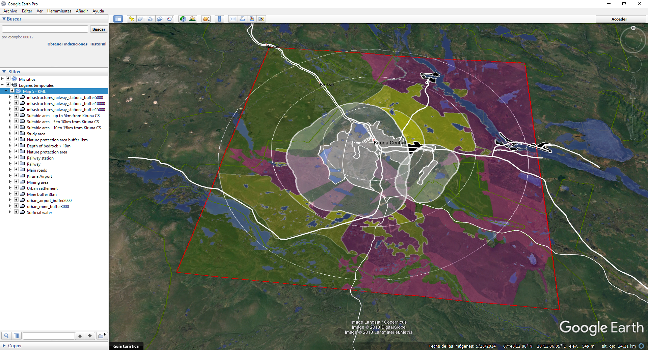

**Figure LAB5.3.3** – KML map version of the analysis of the city of Kiruna and surroundings for the relocation of the city. This image is a preview of the file ‘Assignment 5_MuñozRodríguez_P_ map 3.kmz’, which has been included within the documents submitted for GIS1 assignment 5.

**LAB5.4 – DISCUSSION**

**LAB5.4.1**

**Describe how the produced maps effectively fulfils the purpose described in LAB5.1, and how this differs for each of the maps.**

As previously described in Lab5.1, the purpose of these maps is to show a number of factors that will have influence on the selection of a suitable location for the future city of Kiruna.

When it comes to its communicative function, the maps should clearly show the following elements/layers:

* Current city of Kiruna, mining activity area, airport area, and roads/railway infrastructures.
* Conditions of minimum distance to certain areas such as nature protection areas, Kiruna Airport area, and mining activities areas.
* Other conditions, such as maximum depth of bedrock of 10m, have been established in order to provide a stable base for the future city. Surface water areas should be obviously ruled out too.
* Selected suitable areas as a result of the analysis, which should be clearly highlighted from the rest of layers.

Map 1, over a hillshade model, takes advantage of combining greyscale and colour layers to differentiate between existing areas, factors and results.

The existing city, the mine and the airport, as well as the existing railway/roads infrastructures, have been depicted using greyscale, whereas factors have been depicted in different colours, so that it makes it significantly easier to understand their overlaps, and also to show the areas where these conditions have no influence. These areas have been highlighted from the rest, since they will be the most suitable areas, according to the conditions established.

Map 2 must use a wide range of grey hatches in order to distinguish the different factors and existing areas. The hillshade model has been removed from the map in this case, since it highly saturates the image, and reduces the possibilities of using transparent solid hatches, e.g. for representing factors.

Map 3 must be further simplified in order to visualise clear information on a Google Earth Pro map. A combination of transparent solid hatches and colour polylines of different thicknesses permits to have a sufficient variety of styles to represent all factors and results. Although not having the same graphic quality as maps 1 and 2, its dynamicity while navigating makes obviously all the difference.

**LAB5.4.2**

**How can maps be used as communication tools?**

It cannot be denied that maps have a huge relevance as a communication tool. Not only are these considered as indispensable for planning purposes, but also they are an absolutely essential support in decision making processes (J. Hauck et al., 2013, p27).

As a communication tool for decision support, it could be said that maps:

* are useful in “*identifying and framing problems*” (J. Hauck et al., 2013, p27). They can help to identify conflicts and also synergies between different aspects shown on the map, as well as to obviously give a physical location to the considered issues.
* are “*an opportunity to highlight and illustrate complex problem situations*” (J. Hauck et al., 2013, p27). Maps are a powerful tool, which can be used to combine or overlay information in order to show conflicts or opportunities that only this combination could evidence.
* have a high value in “*initiating discussions*” and especially to “*render visually the different options available*” (J. Hauck et al., 2013, p27), which is important not only to show any problems happening, but also to start to shed some light on them.
* are essential “for mitigating impacts of natural hazards” (Meyer et al., 2012, p1701). As per the European Commission, flood maps “provide essential information for the public but are also important tools for planning authorities and the insurance industry” (EC, 2004, 2007; cf. also Fuchs et al., 2009).

**What needs to be taken into account to make effective maps?**

By paying attention at what possible problems and challenges during the mapping process are, some conclusions and recommendations could be extracted from them:

* End-user needs should be the first factor to take into account2. According to Meyer et al. (2012) regarding to flood maps, “*The RISK MAP project examined how end-user participation in the mapping process may be used to overcome these barriers and enhance the communicative power of flood maps, fundamentally increasing their effectiveness*” 2. By considering user-specific needs, contents of maps could be clearly improved. These needs will differ depending on who the final user is, e.g. strategic planning authorities, emergency management, public will certainly have different needs (Meyer et al., 2012, p1708-1710). However, “*user-specific print-out versions should be produced for the most important user groups*”, as “*the existence of … map servers does not guarantee that some users (e.g. the public) recognise or understand the maps or ensure that such maps are available in case of emergency*” (Meyer et al., 2012, p1714).
* All maps should be relevant for a purpose, so first of all, the following question should be raised: what do we want to explain? “*Salience*”, as defined by Cash et al. (2003), refer to “*the relevance of maps to stakeholders*” 3.
* All information depicted should be credible. According to Cash et al. (2003), “*credibility involves the scientific adequacy of the technical evidence and arguments*”. Scarcity and lack of accuracy of data must be avoided, and factors such as scale and resolution must be conveniently used in order to provide this accuracy (J. Hauck et al., 2013, p29).
* Attention to legitimacy of the information shown should be also paid. According to Cash et al. (2003), “*legitimacy reflects the perception that the production of information and technology has been respectful of stakeholders’ diverging values and beliefs, and unbiased in its conduct*”.

**How can maps be misused as communication tools?**

There are some factors that usually lead to a risk of miscommunication of maps. Some of the following are just an example:

* The unappropriated use of scales can lead to inaccuracies of maps, not only when a wrong scale is used to represent a map, but also when layers of different scales are overlaid to extract certain information. Maps with wrong scales should not take part in decision making, since their inaccuracies would communicate wrong information (J. Hauck et al., 2013, p29).
* Also resolution can lead to similar issues, if the necessary attention is not paid. In frequent occasions in which detailed data is not available, comparing or overlaying information with different resolution, which will certainly have different grade of accuracy (J. Hauck et al., 2013, p29), can also lead to significant mistakes and even hinder many GIS operations.
* Some maps do not incorporate “*local stocks of knowledge*” 2, but they just include general information. These are in fact “*an information tools rather than a communication tool*” (Meyer et al., 2012, p1701).

**REFERENCES**

1. Hauck, J., Görg, C., Varjopuro, R., Ratamäki, O., Maes, J., Wittmer, H., & Jax, K. (2013). “Maps have an air of authority”: Potential benefits and challenges of ecosystem service maps at different levels of decision making. Ecosystem Services, 4, 25-32. doi:10.1016/j.ecoser.2012.11.003.
2. Meyer, V., Kuhlicke, C., Luther, J., Fuchs, S., Priest, S., Dorner, W., . . . Scheuer, S. (2012). Recommendations for the user-specific enhancement of flood maps. Natural Hazards and Earth System Science, 12(5), 1701-1716. doi:10.5194/nhess-12-1701-2012.
3. Cash, D.W., Clark, W.C., Alcock, F., Dickson, N.M., Eckley, N., Guston, D.H., Jager, J., Mitchell, R.B., 2003. Knowledge systems for sustainable development. Pro- ceedings of the National Academy of Sciences of the United States of America 100 (14), 8086–8091.
4. European Commission: Communication from the Commission to the Council, the European Parliament, the European Economic and Social Committee and the Committee of the Regions, Flood Risk Management: Flood Prevention, Protection and Mitigation, European Commission, Brussels, 2004.
5. European Commission (Ed.): Risk Assessment and Mapping Guidelines for Disaster Management, Commission Staff Working Paper, Brussels, SEC (2010) 1626 final, 2010.
6. Fuchs, S., Spachinger, K., Dorner, W., Rochman, J., and Serrhini, K.: Evaluating cartographic design in flood risk mapping, Environ. Hazards, 8, 52–70, 2009.

**ISSUED FILES**

* **Assignment 5_MuñozRodríguez_P.docx**
* **Assignment 5_MuñozRodríguez_P_incoming data register.xlsx**
* **Assignment 5_MuñozRodríguez_P_maps 1&2.pdf**
* **Assignment 5_MuñozRodríguez_P_map 3.kmz**
* **Assignment 5_MuñozRodríguez_P_geodatabase.gdb**

(the raster files ‘DEM_kiruna’, ‘DEM_kiruna_hillshade’, ‘orto_1960’, ‘orto_current’, ‘SGU_depth_to_bedrock_rectified’, and ‘topo_base’ have been removed to reduce the size of the file)